**AIDS Lab**

**EXPERIMENT NO. 6**

**Aim**: To implement Fuzzy Membership Functions.

**Theory**:

Fuzzy membership function is used to convert the crisp input provided to the fuzzy inference system. Fuzzy logic itself is not fuzzy, rather it deals with the fuzziness in the data. And this fuzziness in the data is best described by the fuzzy membership function. Fuzzy inference system is the core part of any fuzzy logic system.

Formally, a membership function for a fuzzy set A on the universe of discourse X is defined as µA: X → [0, 1], where each element of X is mapped to a value between 0 and 1. This value, called membership value or degree of membership, quantifies the grade of membership of the element in X to the fuzzy set A. Here, X is the universal set and A is the fuzzy set derived from X.

Fuzzy membership function is the graphical way of visualizing the degree of membership of any value in a given fuzzy set. In the graph, X axis represents the universe of discourse and Y axis represents the degree of membership in the range [0, 1]. The different features of Membership Functions are:

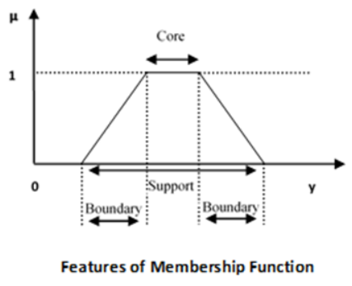

1. Core: For any fuzzy set A˜, the core of a membership function is that region of the universe that is characterised by full membership in the set. Hence, core consists of all those elements y of the universe of information such that



1. Support: For any fuzzy set A˜, the support of a membership function is the region of the universe that is characterised by a nonzero membership in the set. Hence core consists of all those elements y of the universe of information such that



1. Boundary: For any fuzzy set A˜, the boundary of a membership function is the region of the universe that is characterised by a nonzero but incomplete membership in the set. Hence, core consists of all those elements y of the universe of information such that



Following are a few important points relating to the membership function:

* Membership functions characterize fuzziness (all the information in a fuzzy set), whether the elements in fuzzy sets are discrete or continuous.
* Membership functions can be defined as a technique to solve practical problems by experience rather than knowledge.
* Membership functions are represented by graphical forms.
* Rules for defining fuzziness are fuzzy too.

**Code and Output**:

The membership function of a fuzzy set is a generalization of the indicator function in classical

sets. In fuzzy logic, it represents the degree of truth as an extension of valuation. Degrees of truth are often confused with probabilities, although they are conceptually distinct, because fuzzy truth represents membership in vaguely defined sets, not likelihood of some event or condition.

| !pip install pyit2fls from numpy import linspace import matplotlib.pyplot as plt from pyit2fls import zero_mf, singleton_mf, const_mf, tri_mf, ltri_mf, rtri_mf, \  trapezoid_mf, gaussian_mf |
| --- |

In the following code, we will see various fuzzy membership functions. These functions are mathematically very simple. Fuzzy logic is meant to deal with the fuzziness, so use of complex membership functions would not add much precision in final output.

| domain = linspace(0., 1., 1001)  zero = zero_mf(domain) singleton = singleton_mf(domain, [0.5, 1.]) const = const_mf(domain, [1.]) tri = tri_mf(domain, [0., 0.5, 1., 1.]) ltri = ltri_mf(domain, [0.5, 1., 1.]) rtri = rtri_mf(domain, [0.5, 0., 1.]) trapezoid = trapezoid_mf(domain, [0., 0.3, 0.8, 1., 1.]) gaussian = gaussian_mf(domain, [0.5, 0.1, 1.]) |
| --- |

Constant membership function assigns membership value 1 to all values of x, and All Zero membership function assigns value 0 to the rest of all.

| plt.figure() plt.plot(domain, zero, label="All zero MF") plt.plot(domain, const, label="Const MF") plt.grid(True) plt.legend() plt.xlabel("Domain") plt.ylabel("Membership function") plt.show() |
| --- |

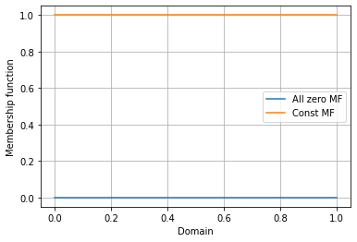

Singleton membership function assigns membership value 1 to a particular value of x, and assigns value 0 to rest of all.

| plt.figure() plt.plot(domain, singleton, label="Singleton MF") plt.grid(True) plt.legend() plt.xlabel("Domain") plt.ylabel("Membership function") plt.show() |
| --- |

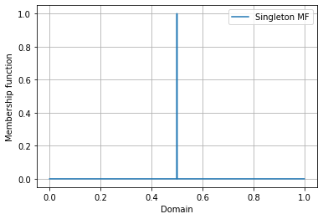

This is one of the most widely accepted and used membership functions (MF) in fuzzy controller design. The triangle which fuzzifies the input can be defined by three parameters a, b and c, where c defines the base and b defines the height of the triangle.

| plt.figure() plt.plot(domain, tri, label="Triangular MF") plt.plot(domain, ltri, label="Left triangular MF") plt.plot(domain, rtri, label="Right triangular MF") plt.grid(True) plt.legend() plt.xlabel("Domain") plt.ylabel("Membership function") plt.show() |
| --- |

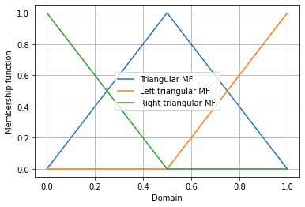

Trapezoidal membership function is defined by four parameters: a, b, c and d. Span b to c represents the highest membership value that element can take. And if x is between (a, b) or (c, d), then it will have membership value between 0 and 1.

| plt.figure() plt.plot(domain, trapezoid, label="Trapezoid MF") plt.grid(True) plt.legend() plt.xlabel("Domain") plt.ylabel("Membership function") plt.show() |
| --- |

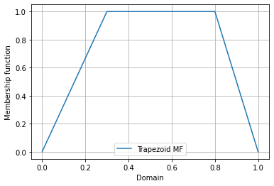

A Gaussian MF is specified by two parameters {m, σ} and in this function, m represents the mean / center of the gaussian curve and σ represents the spread of the curve.

| plt.figure() plt.plot(domain, gaussian, label="Gaussian MF") plt.grid(True) plt.legend() plt.xlabel("Domain") plt.ylabel("Membership function") plt.show() |
| --- |

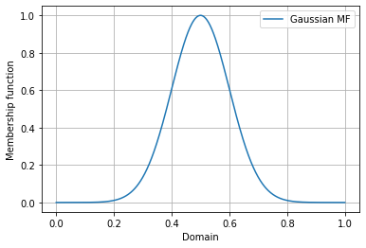

**Conclusion**:

Thus we studied an overview of fuzzy membership functions, various forms of fuzzy membership functions, its features and uses.